Session 4: Data Retrieval with SELECTTrainer Coverage:SELECT queries, filtering, sorting, aliases.Aggregate functions (SUM, AVG, COUNT).Demo: Generate “total expenses” by category.Pending

Q:-1. Create a table called Playlist with columns: id, song_name, artist, genre, and play_count. Insert at least 5 sample records representing your favorite songs from Spotify.

Create Table:-

create table playlist(
id integer primary key auto_increment,
song_name text,
artist text,
genre text,
play_count integer);

Insert Data:-INSERT INTO playlist(song_name, artist, genre, play_count) VALUES
('Chaleya', 'Anirudh Ravichander', 'Bollywood', 180),
('Heeriye', 'Jasleen Royal', 'Romantic', 140),
('O Maahi', 'Arijit Singh', 'Bollywood', 220),
('Blinding Lights', 'The Weeknd', 'Pop', 300),
('Stay', 'Justin Bieber', 'Pop', 270);

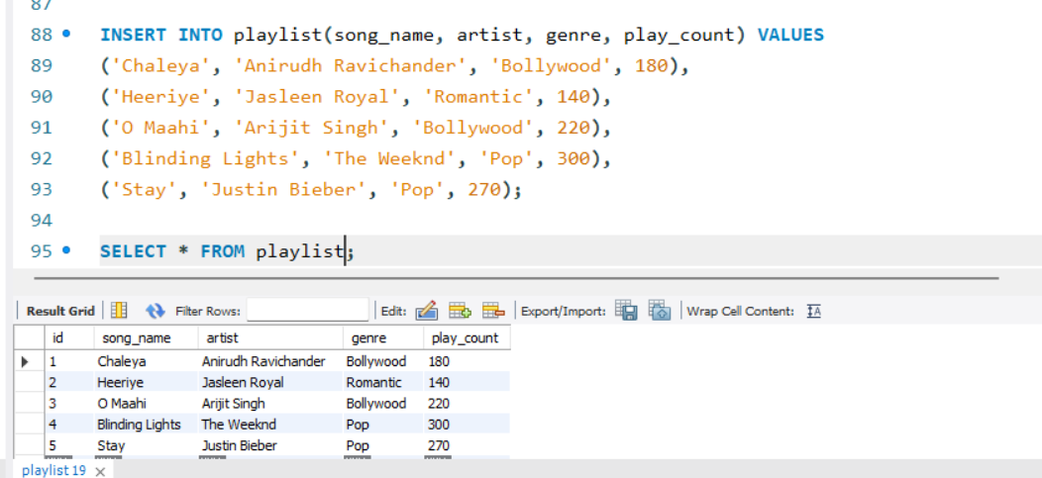
Q:-2. Write a SELECT query to display only the song_name and artist from the Playlist table, but show the artist column as 'Singer' using an alias.

select song_name,artist as singer from playlist;

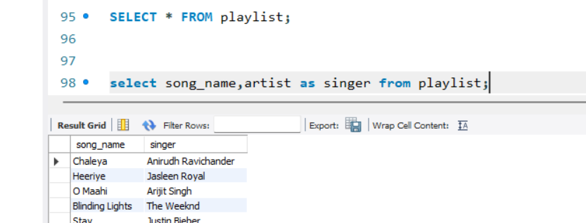

Q:-3. Write a SELECT query to find all songs in the Playlist table where the genre is 'Pop' and play_count is greater than 100. Sort the results by play_count in descending order.

select *from playlist where genre ='Pop' and play_count>100 order by play_count desc;

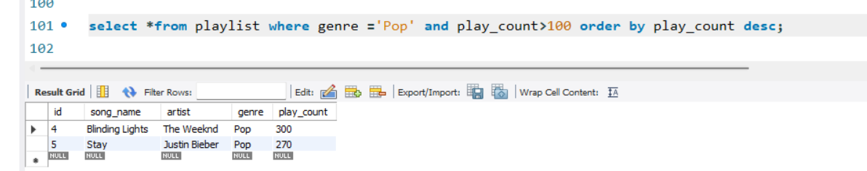

Q:-4. Use the COUNT aggregate function to find out how many songs in your Playlist table belong to the genre 'Hip-Hop'.

select count(*) as hip_hop_songs from playlist where genre ='Hip-Hop';

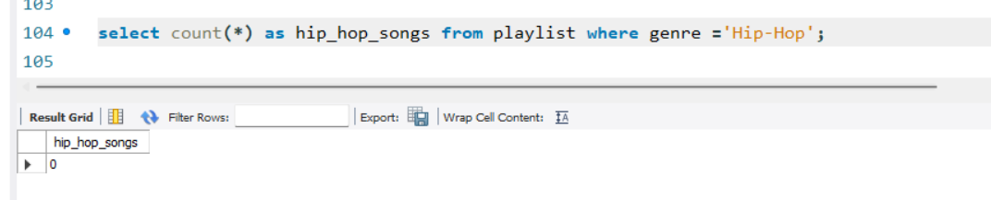
Q:-5. Write a SELECT query that shows the total number of plays (SUM of play_count) for each genre in your Playlist table, grouped by genre.<br><br><em><strong>Hint:</strong> Use GROUP BY with the SUM function to aggregate play counts by genre.</em>

select genre,sum(play_count) as total_plays from playlist group by genre;

